GST Practice Steps:
- Create company
- Activate GST in company (F11-Statutory)
- Create GST Ledgers ( Duty ledgers)
- Create Sales-Purchase Ledger with GST Applicable
- Create Stock Items and Group. Set up Tax rates
- Create Ledger for Suppliers and Customers ( or use Cash)
- Generating GST vouchers
- Review of work done

GST rate can be set at following levels:
- Company Level
- Sales/Purchase Ledger Level
- Stock Group Level
- Stock Item Level
In this practice, the GST will be set at Stock Item Level

Step 1: New Company in Tally.ERP9
Create a company Swayam Education Pvt Ltd based in Odisha.(Pin Code: 751004)

Step 2: Activate GST for your Company in Tally.ERP9
On creation of the company To use Tally will ask for features to enabled. For GST compliance, you need to activate the GST feature. Once activated, GST-related features are available in ledgers, stock items, and transactions, and GST returns can be generated.

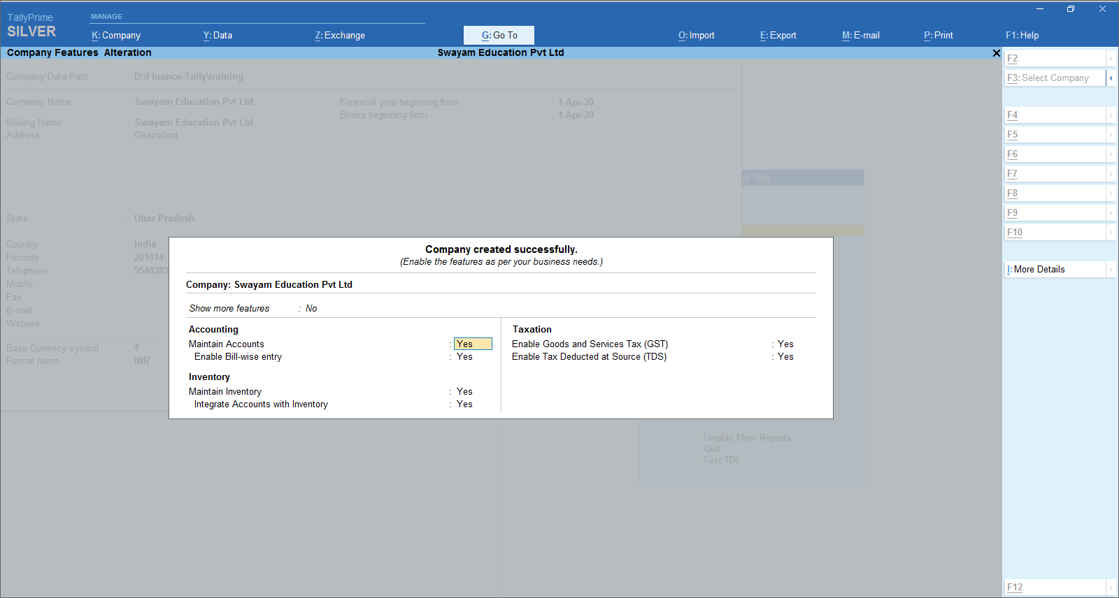

3. Enable Goods and Services Tax (GST) - Yes.
4. Set/alter GST details - Yes.
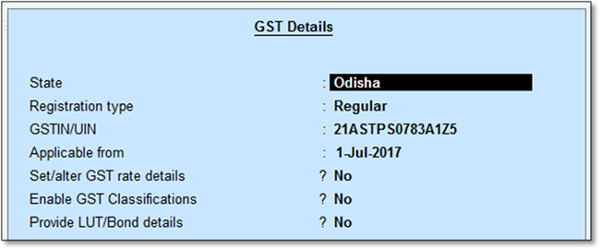
State: Displays the state you have selected for your company. Helps in identifying local and interstate transactions. If you change the state, it will be updated in the company details.
5. Specify the GSTIN/UIN for the business. This can be printed in the invoices as required. You can specify this later.
6. Specify Applicable from date. GST will be applicable for your transactions from this date onwards.
You can record transactions using the ledgers with GST details, and print invoices with GSTIN.

Step 3: Creating GST Ledgers - CGST-SGST-IGST in Tally.ERP9
To account for the different taxes to be paid under GST (central tax, state tax, union territory tax, integrated tax, and cess), you have to create a tax ledger for each tax type.
In our above Practical Examples….the following GST Ledgers will be created :
i. SGST [ State Tax at the time of Sale/Purchase Locally ]
ii. CGST [ Central Tax at the time of Sale/Purchase Locally ]
iii. IGST [ Integrated Tax at the time of Sale/Purchase from Outside State ]
iv Purchase Ledger
v Sales Ledgers

i. To create ‘SGST’ ledger
1. Gateway of Tally > Masters > Create > Accounting Masters> Ledgers >
2. In Under, select Duties & Taxes.
3. Select GST as the Type of duty/tax.
4. Select State Tax as the Tax type.
Note : Percentage of Calculation should be 0% ( Don’t Change ) due to multiple Tax Rate

Similarly, you can create ledgers of all above 5 Ledgers ( i to v ) by selecting the relevant Tax type under GST.
ii. To create ‘CGST’ ledger

Gateway of Tally > Masters > Create > Accounting Masters> Ledgers >

2. In Under, select Duties & Taxes.
3. Select GST as the Type of duty/tax.
4. Select Central Tax as the Tax type.
Note : Percentage of Calculation should be 0% ( Don’t Change ) due to multiple Tax Rate
ii. To create ‘IGST’ ledger
Gateway of Tally > Masters > Create > Accounting Masters> Ledgers >

2. In Under, select Duties & Taxes.
3. Select GST as the Type of duty/tax.
4. Select Integrated Tax as the Tax type.
Note : Percentage of Calculation should be 0% ( Don’t Change ) due to multiple Tax Rate

Step 4: Creating Sales/Purchase Ledger : GST-Sales, GST-Purchase
To Create a Sales Ledger i.e. GST-Sales
1. Gateway of Tally > Masters > Create > Accounting Masters> Ledgers >
2. Enter the Name of the Sales ledger i.e. GST-Sales
3. Select Sales Account from the List of Groups in the Under field.
4. Set the option Inventory values are affected? to Yes ,.
5. Is GST Applicable - Applicable.
6. Set/alter GST Details - No,
Don’t specify the details in the GST Details because GST Rate specified in all Items (specified above) will automatically Calculate the CGST and SGST ,.
7. Select the Type of supply. By default the type of supply is set to Goods.
8. Press Ctrl + A to save.
[ Note : Only one Ledger i.e. GST-Sale will be created for all type of GST Sales ]

[ Note : Similarly Create GST Purchase Ledger ]

Step 5: Creating Stock Items and Stock Groups for GST Compliance
If the items you sell have different tax rates, update your stock item masters or stock groups with the applicable GST rates, and select the type of supply, as applicable.
5.1 Create Unit of Measurement
Gateway of Tally > Masters > Create > Inventory Masters> Unit >

5.2 Create Stock Item
In case you need different tax rates for different items, modify the stock items to include the applicable tax rates.
Gateway of Tally > Masters > Create > Inventory Masters> Stock Items >

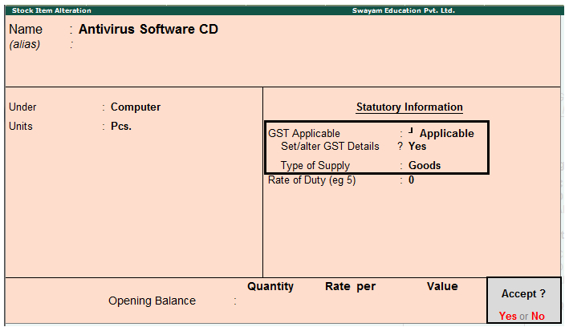
2. Set/alter GST Details: Yes to specify the details in the GST Details screen, and save.
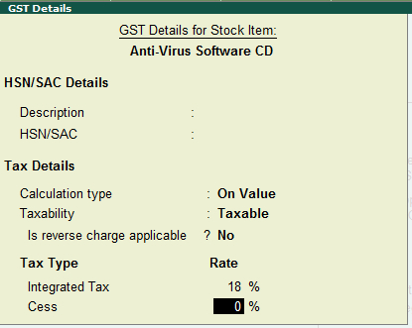
Note: If you have modified the tax rates before, press Alt + L to view the history of tax rate changes.
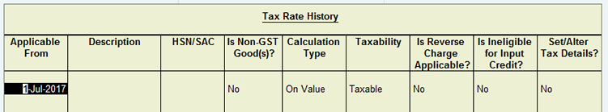
3. Select the Type of supply.
4. Press Ctrl + A to save.
>> Create & Setup the GST Rate of the following Stock Items as per above Setup >>

Name of Items | UoM | GST Rate
Monitors | Pcs | 28%
Hp- Laptop | Pcs | 18%
Mi Note-4 Mobiles | Pcs | 12%
Antivirus Software CDs | Pcs | 18%

Step 6: Creating Supplier and Customer Ledgers
To Create Ledger
- Go to Gateway of Tally > Accounts Info. > Ledgers > Create.
- Suppliers should be created under “Sundry Creditors” and should enter correct GSTIN
- Customers should be created under “Sundry Debtors” and should enter correct GSTIN

Step 7: Create Vouchers and Calculation of GST ( IGST, CGST & SGST)
Go to Gateway of Tally > Accounting Voucher > Sales/Purchase (etc) on right side of the screen.
The following Transaction has been done by the Swayam Education Pvt. Ltd. Based on this transaction compute the GST payable to the Government.
1. Purchase from Raj Infotech-Local Dealer, (21AAACI1681G1Z1)
5 CDs of Antivirus Software @ Rs. 800 each, with Input GST rate @ 18%. i.e. Rs.. 720 - [ CGST (9%) Rs.360 and SGST (9%) Rs.360 ]
2. Purchase from Microtek India Ltd.-Local Dealer , (21BFCPS1586M1Z6)
10 Monitors @ Rs. 4000 each, with Input GST @ 28% i.e. Rs.11,200 – [ CGST (14%) Rs.5600 and SGST (14%) Rs. 5600. ]
3. Purchase 2 ‘Hp-Laptop’ @ Rs. 45,000 with Input IGST @ 18% i.e. Rs. 16,200.
And
2 Mi-Note 4 Mobiles @ Rs. 10,000 each with Input IGST 12% i.e. Rs.2,400 – in Cash from Outside State – West Bengal from Registered Dealer ( with GSTN – 22AAAAA0000A1Z5 ) .
4. Sale of 5 Antivirus Software CDs @ Rs.1500 to Rajib Roy & Sons with output GST 18% i.e. Rs. 1350 – [CGST (9%) Rs. 675 and SGST (9%) Rs.675 ]
5. Sale of 10 Monitors @ Rs.4500 , to H. Goenka Traders with Output GST @ 28% i.e. Rs. 12600 – [ CGST (14%) Rs. 6300 and SGST (14%) Rs. 6300 ]
6. Sale of 2 ‘Hp-Laptop’ @ Rs 50,000 with Output GST @ 18% i.e. Rs.18,000 [ CGST (9%) Rs.9,000 and SGST (9%) Rs.9,000 ] in Cash within State
7. Sale of 2 Mi-Note 4 Mobiles Outside State @ Rs. 15,000 each with Output IGST 12% i.e. Rs. 3600 in Cash to a Party in Outside State i.e. Andhra Pradesh.

Step 8: Review of the work
- Go to Gateway of Tally > Display -> Day Book

For PURCHASE & PAYMENT : | IGST | CGST | SGST
For Transaction 1 : GST paid to party on assessable value of Rs.4,000 @ 18 % GST is Rs. 720 |  | 360 | 360
For Transaction 2 : GST paid to Party on the assessable Value of Rs. 40,000 @ 28% GST is Rs. 11,200 |  | 5600 | 5600
For Transaction 3 : IGST paid on the assessable Value of Rs. 90,000 @ 18% GST is Rs. 16,200 & Rs. 20,000 @ 12% GST is Rs. 2,400 [ 16200+2400] | 18600
Total of Input GST [ IGST, SGST & CGST] | 18600 | 5960 | 5960
For SALES :
For Transaction 4 : GST received from Party on assessable value of Rs. 7,500 @ 18% GST Rs. 1350 |  | 675 | 675
For Transaction 5 : GST received from Party on assessable value of Rs. 45,000 @ 28 % GST Rs. 12600 |  | 6300 | 6300
For Transaction 6 : GST received on the assessable Value of Rs. 1,00,000 @ 18% GST is Rs. 18,000. |  | 9000 | 9000
For Transaction 7 : IGST received on the assessable Value of Rs. 30,000 @ 12% IGST is Rs.3600 for sale outside State. | 3600
Total Output GST [ IGST, SGST & CGST] | 3600 | 15,975 | 15,975

Table of GST Adjustment with Journal Voucher Entries
Particulars | IGST | CGST | SGST
Output GST Liability | 3600 | 15,975 | 15,975
Less : Input GST Credit
Input CGST |  | 5960
Input SGST |  |  | 5960
Input IGST | 3600 | 10015 | 4985
Amount Payable i.e SGST only | NIL | NIL | 5030

Any IGST credit will first be applied to set off IGST and then CGST.
Balance if any will be applied to setoff SGST.
So out of total input IGST of Rs. 18,600, firstly it will be completely setoff against IGST i.e. 3600. Then balance Rs.15,000 against CGST i.e. Rs. 10015 and remaining Balance of Rs. 4985 against SGST
From the total Output GST Rs.35,550, only Output SGST of Rs. 5030 is payable.
So the Set-Off Entries will be -
1. Setoff against CGST Output
Output CGST A/c Dr. ……… 15975
To Input CGST A/c 5960
To Input IGST A/c 10015
2. Setoff against SGST Output
Output SGST A/c Dr. ……… 15975
To Input SGST A/c 5960
To Input IGST A/c 4985
To Output SGST Payable A/c 5030
3. Setoff against IGST Output
Output IGST A/c Dr. ……… 3600
To Input IGST A/c 3600
4. Final Payment of Output SGST Payable of Rs. 5030
Output SGST Payable A/c Dr. ……… 5030
To Bank A/c 5030

